**Self-Quarantine Safety Protection Application**

**RESEARCH REPORT**



**SUBMITTED BY**

Sanwal Khan 2018-ag-8234

Muhammad Sohaib 2018-ag-8220

Ayesha Sadiqa 2018-ag-8198

**Supervisor: Ms Sidra Shahid**

**A RESEARCH REPORT SUBMITTED IN PARTIAL FULFILLMENT OF REQUIREMENT FOR THE DEGREE OF**

*Bachelors of Science*

*IN*

*COMPUTER SCIENCE*

**DEPARTMENT OF COMPUTER SCIENCE**

**FACULTY OF SCIENCES**

**UNIVERSITY OF AGRICULTURE FAISALABAD**

**DECLARATION**

I hereby declare that the contents of the report

“**Self-Quarantine Safety Protection Application”**

is project of our own research and no part has been copied from any published source (except the references). I further declare that this work has not been submitted for award of any other diploma/degree. The university may take action if the information provided is found false at any stage. In case of any default the scholar will be proceeded against as per UAF policy.

Sanwal Khan (2018-ag-8234)

Muhammad Sohaib (2018-ag-8220)

_________________

Ayesha Sadiqa 2018-ag-8198

**CERTIFICATE**

To,

The Controller of Examinations,

University of Agriculture,

Faisalabad.

The supervisory committee certifies that **Sanwal Khan (2018-ag-8234), Muhammad Sohaib (2018-ag-8236) and Ayesha Sadiqa (2018-ag-8198)** has successfully completed their project in partial fulfillment of requirement for the degree of BSCS Computer Scienceunder our guidance and supervision.

_____________________________________

Ms Sidra Shahid

Supervisor

_______________________________________

Salman Afsar

In charge,

Department of Computer Science

**ACKNOWLEDGEMENT**

I thank all who in one way or another contributed in the completion of this report. First, I thank to ALLAH ALMIGHTY, most magnificent and most merciful, for all his blessings. Then I am so grateful to the Department of Computer Science for making it possible for me to study here. My special and heartily thanks to my supervisor ***Ms. Sidra Shahid*** who encouraged and directed us. His challenges brought this work towards a completion. It is with his supervision that this work came into existence. For any faults I take full responsibility. I am also deeply thankful to my informants. I want to acknowledge and appreciate their help and transparency during my research. I am also so thankful to my fellow students whose challenges and productive critics have provided new ideas to the work. Furthermore, I also thank my family who encouraged me and prayed for me throughout the time of my research. May the Almighty God richly bless all of you.

**Abstract**

The current Covid-19 health crisis, caused by Covid-19 has produced a devastating toll both in terms of human life loss and economic disruption. With high transmissibility and no effective vaccine or therapy, COVID-19 is now a global pandemic. Effective screening of Covid-19 can enable quick and efficient diagnosis of COVID-10 and can mitigate the burden on healthcare systems. To tackle this situation, proper quarantining and monitoring of already infected patients are very essential. In recent time, mobile technologies have expanded exponentially in both emerging and developed countries. A lot of measures have been taken to reduce the rate of community transmission and despite the various measures taken; the rate of the infection and mortality rate is still very high. Mobile phone tracking approach is a powerful tool in the fight against the COVID-19 pandemic.

#### **Acknowledgments**

In the name of Allah, the Most Gracious and the most Merciful, Alhamdulillah, all praises to Allah for the strengths and His blessing in completing this project. We would like to express our deepest gratitude and are thankful to our supervisor **MS. Sidra Shahid** for giving us a chance to work on this emerging system, for supervising this project and providing guidance to make this project successful. We also like to express our deepest feelings of gratitude to our respected faculty members of **Department of Computer Science, University of Agriculture, Faisalabad**. Their invaluable help of constructive comments and suggestions throughout Project work has contributed to the success of this research and finally we are successful.

Regards,

Sanwal Khan

Muhammad Sohaib

Ayesha Sadiqa

##### Table of Contents

**Chapter 1** 1

**1.1 Introduction** 1

**1.2 Problem Description** 2

**1.3 Project Objectives** 3

**1.4 Project Scope** 3

**1.5 Tools and technologies** 3

1.5.1 Tools: 3

1.5.2 Programming Languages: 3

**Chapter 2** 5

**Review of literature** 5

**2.1 Literature review** 5

**2.2 Related Work** 5

**2.3 Applications** 7

**2.4 Proposed Solution** 9

**Chapter 3** 10

**Requirement Specification** 10

**3.1 Requirement Specification** 10

**3.2 Existing System of Project** 10

**3.3 Proposed System of Project** 10

**3.4 Functional Requirements** 10

**3.5 Non-Functional Requirements** 11

**3.6 Use Case Diagram** 12

**3.7 Detailed Use Case** 12

**4.2 System Architecture** 17

**4.3 Process Mode** 17

**4.4 Data Flow Diagram** 19

**4.5 Sequence diagram** 20

**4.7 GUI Design of Project** 22

**Chapter 5** 25

**System implementation** 25

**5.1 System Implementation** 25

**5.2 Tools and technologies** 25

**5.2.1 Android Studio** 25

**5.2.2 Firebase** 26

**5.3 Libraries and Dependencies** 26

**Chapter 6** 28

**System Testing and Evaluation** 28

**6.1 System Testing and Evaluation** 28

**6.2 Graphical User Interface Testing** 28

**6.3 Unit Testing** 28

**6.4 System Testing** 28

**6.5 Usability Testing** 29

**6.6 Performance Testing** 29

**6.7 Security Testing** 29

**6.8 Test Cases** 29

**Conclusion** 32

**7.1 Conclusion** 32

**7.2 Future Enhancements** 32

Table of Figures

Figure 1.1 Safety Measures .................................................................................................................. 8 Figure 2 Covid-19 ................................................................................................................................. 9 Figure 3 Android Studio ..................................................................................................................... 11 Figure 4 Self-isolation tips .................................................................................................................. 13 Figure 5 Symptoms Severity graph .................................................................................................... 14 Figure 6 Covid related apps ................................................................................................................ 15 Figure 7 Covid Symptom Tracker App ................................................................................................ 16 Figure 8 Aarogya Setu ........................................................................................................................ 16 Figure 9 COVID-19 Gov PK .................................................................................................................. 17 Figure 10 Use Case Diagram ............................................................................................................... 21 Figure 11 User Registration. ............................................................................................................... 22 Figure 12 Patient Self-Diagnosis ......................................................................................................... 23 Figure 13 Patient Health Monitoring ................................................................................................. 23 Figure 14 Update Information ...........................................................................................................

24 Figure 16 Monitoring Patient's Health ............................................................................................... 25 Figure 17 Medical Assistance for Critical Patients ............................................................................. 26 Figure 18 Remove User ...................................................................................................................... 27 Figure 19 Client-server architecture .................................................................................................. 28 Figure 20 Process Model Diagram ..................................................................................................... 29 Figure 21 Data Flow Diagram ............................................................................................................. 30 Figure 22 Interaction with Registration module ................................................................................ 31 Figure 23 Interaction with diagnosis module..................................................................................... 32 Figure 24 Class Diagram ..................................................................................................................... 33

# **Chapter 1**

**Introduction**

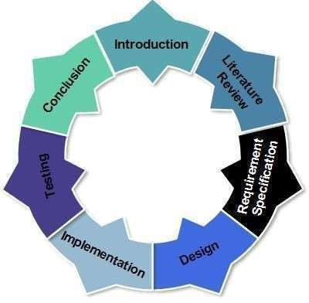

## **1.1 Introduction**

The sudden emergence and rapid global spread of a virus is called pandemic.[1] For the third time in as many decades, a zoonotic coronavirus has crossed species to infect human populations. Coronaviruses are a large family of viruses that can cause illness in animals or humans. In humans there are several known coronaviruses that cause respiratory infections. This virus, provisionally called 2019-nCoV, was first identified in Wuhan, China, in persons exposed to a seafood or wet market.[2] Currently coronavirus has infected more than 112,726,316 people and killed more than 2,498,395 people.

Because of its fatal nature the further spread of coronavirus needs to be stopped. To limit the spread of coronavirus the following safety measures should be taken: -

Maintain at least a 1-metre distance between yourself and others to reduce your risk of infection when they cough, sneeze or speak. Maintain an even greater distance between yourself and others when indoors. The further away, the better.

Stay home and self-isolate even if you have minor symptoms such as cough, headache, mild fever, until you recover. Call your health care provider or hotline for advice. Have someone bring you supplies. If you need to leave your house or have someone near you, wear a medical mask to avoid infecting others. [3]

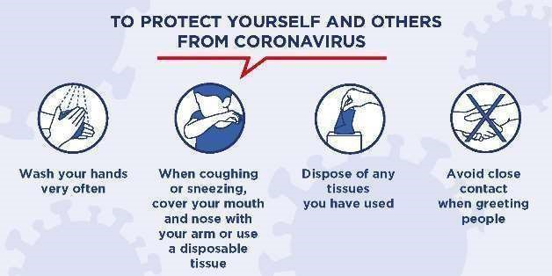

Figure 1.1 Safety Measures

The governments of many developed countries approved emergency regulations allowing mass location tracking of citizens as part of the national effort to slow the pandemic of coronavirus disease 2019 (COVID-19)

In the domain of maintaining distance as a part of limiting the spread of coronavirus this project will play an important role in monitoring coronavirus infected patients.

This project will also help the relevant authorities or government in tracking the disease through android app.



Figure 2 Covid-19

## **1.2 Problem Description**

The spread of epidemics has always threatened humanity. Understanding transmission of the virus is key to its containment and future prevention.[3]. This pandemic continues to challenge medical systems worldwide in many aspects, including sharp increases in demands for hospital beds and critical shortages in medical equipment, while many healthcare workers have themselves been infected. Thus, the capacity for immediate clinical decisions and effective usage of healthcare resources is crucial. Effective screening of SARSCoV-2 enables quick and efficient diagnosis of COVID-19 and can mitigate the burden on healthcare systems. In underdeveloped countries like Pakistan there is no real time monitoring of infected Covid-19 patients which in result is spreading coronavirus.

## **1.3 Project Objectives**

The objective of our project is to develop an app which will help to stop the spread of COVID-19 by providing health monitoring feature to the patients and the authorities,. Critical patient will be provided medical assistance using the health monitoring feature. The application is to be very user-friendly and convenient for all type of users regardless of their age.

## **1.4 Project Scope**

The purpose of this project is to design an android application that helps tracking and monitoring the data of coronavirus infected patients. Through self-diagnosis feature the patient can monitor their health condition. This project can help to stop further spread of COVID-19 and provide medical assistance to the critical patients.

## **1.5 Tools and technologies**

This application has been developed in Java using Android Studio IDE. Patient symptoms are analyzed using Python along with Tensor Flow modules and other libraries.

### 1.5.1 Tools:

* Android Studio

### 1.5.2 Programming Languages:

* Java/Kotlin
* XML
* Javascript
* Python

**1.5.3 Android Studio:**

Android Studio is Android's official IDE. It is purpose-built for Android to accelerate your development and help you build the highest-quality apps for every Android device.



Figure 3 Android Studio

###### **1.5.4 Python**

Python is a Research Purpose Language. We used python to train our machine with the provided dataset to analyze patient’s symptoms and provide an accurate prediction.

###### **1.5.5 XML**

XML stands for Extensible Markup Language. XML is a markup language much like HTML used to describe data. XML tags are not predefined in XML. We must define our own Tags. Xml as itself is well readable both by human and machine. Also, it is scalable and simple to develop. In Android we use xml for designing our layouts because xml is lightweight language so it doesn’t make our layout heavy.

**1.5.5 Java**

Java ME is based on Java SE and is supported by most smartphones and tablets. The Java Platform Micro Edition (Java ME) provides a flexible, secure environment for building and executing applications that are targeted at embedded and mobile devices. We used java to design business logic of our application.

# **Chapter 2**

## **Review of literature**

## **2.1 Literature review**



In this chapter we will discuss some of the research papers and work related to our project by other people to support our project. The information of all the papers added is related to our project that is about covid-19 symptoms and applications to limit and control its spread.

## **2.2 Related Work**

According to Mayo CIinic, self-quarantine or isolation is important for people who have or have been exposed to the disease to stop its further spread. People having symptoms should isolate at home or any other facility. They should stay away from family members and should wear a mask during close contact with someone. If case symptoms get worse, they should contact doctor for medical assistance. Self- quarantine period is usually for 14 days in which the patient has to watch for the signs and symptoms, such as fever cough or shortness of breath.[4]

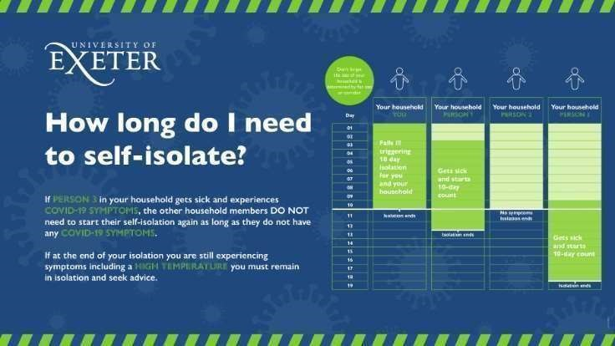

Figure 4 Self-isolation tips

Li J, Chen Z, Nie Y, Ma Y, Guo Q, Dai X [5] analyzed documented symptoms and their associations with disease severity using case series. In this study they examined 655 confirmed cases. They found that fatigue and expectoration are signs of severe COVID-19 infection. Shortness of breath, chest distress and muscle pain are prevalent in severe patients. Shortness of breath is prognostic of severe infection in male patients. They also found out that symptom of fever occurred in 92.1% of the patients but this symptom was not associated with COVID-19 severity.

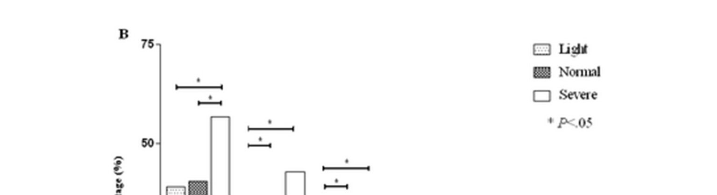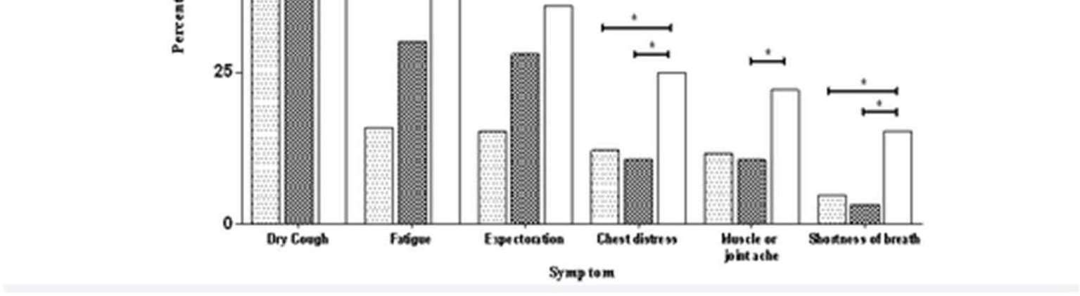

Figure 5 Symptoms Severity graph

Yazeed Zoabi, Shira Deri-Rozov & Noam Shomron suggested that effective screening can help in quick and efficient diagnosis of Covid-19 and can mitigate the burden on healthcare systems. They developed a prediction model that trained on records from 51,831 tested individuals. Their model predicted Covid-19 test results with high accuracy by asking basic questions. There model helped to prioritize testing for COVID-19 when testing resources were limited.

The Coronavirus disease raises unimaginable threats for governments and communities worldwide. In this situation implementation of mobile monitoring for COVID-19 can help model the spatial spread of coronavirus. The governments and scientists are working with mobile communication companies, to assess and visualize the feasibility of control measures. Mobile health applications promote impactful monitoring and regulate techniques for epidemics, they are not restricted to contact detection, social mobilization, navigation, interaction, shriveling and response.

Applications can also support domestic and global initiatives to monitor the spread of COVID-19 epidemic disease. It can also offer medical professionals better means of communicating fast, secure, and accurate directions and knowledge. [6]

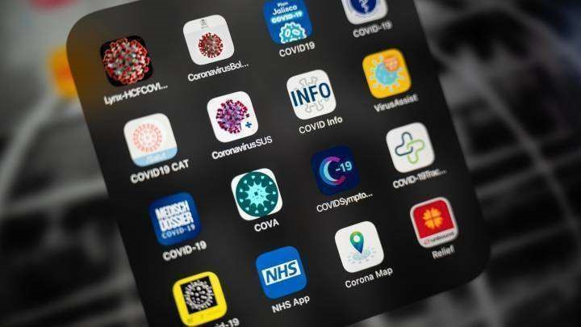

Figure 6 Covid related apps

## **2.3 Applications**

In this pandemic, Uk launched their app “The Covid Symptom Tracker App” to help track the spread of coronavirus across the United Kingdom in real time and collect data of self- reported symptoms and the characteristics of those most at risk. People are asked to provide personal information and list any chronic health conditions. Then they provide information about COVID-19 symptoms they are experiencing. The aim of the app is to help slow the outbreak. [7]

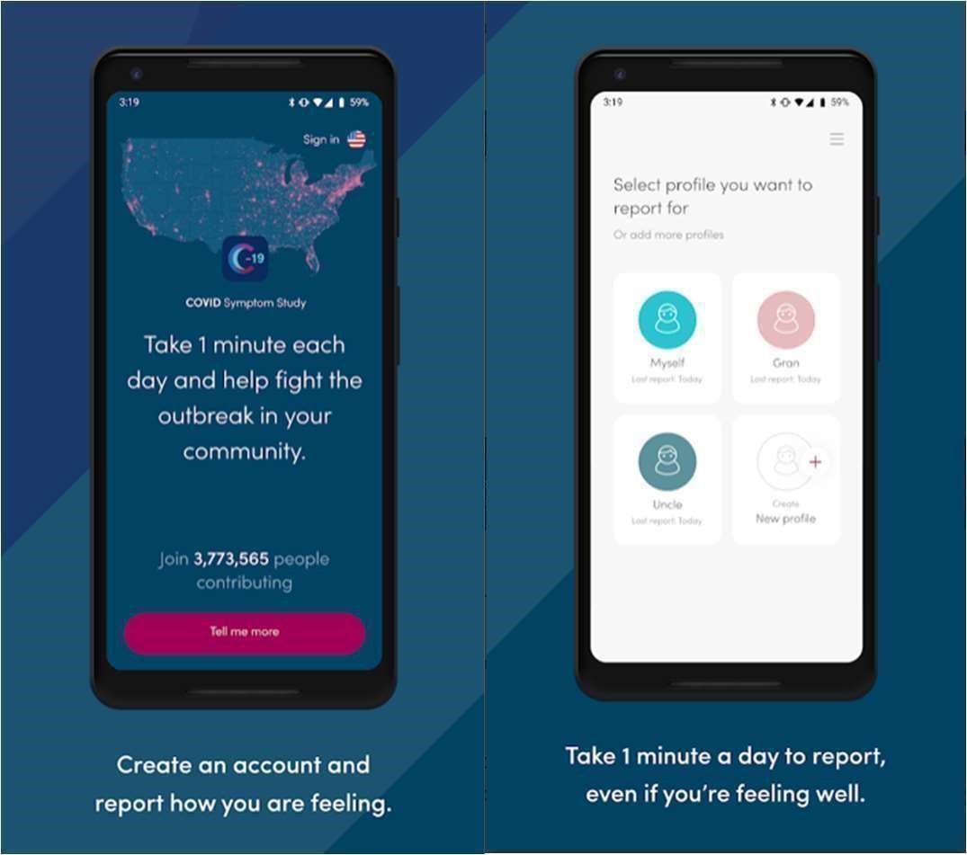

Figure 7 Covid Symptom Tracker App

Another famous application developed for tracking of COVID-19 is Aarogya Setu App in India developed by the National Informatics Centre. The App alarms the user whenever they meet an infected person through Bluetooth and GPS location services. It is available on Google Play Store. Overall it helps the government in keeping track of people who have been tested positive for the virus. But it doesn't provide feature of self-diagnosis. [8]

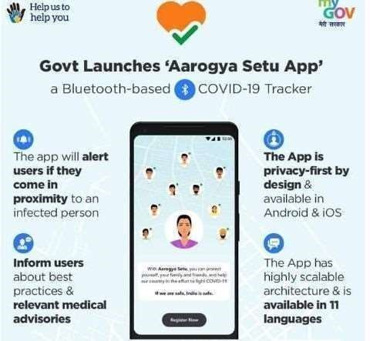

Figure 8 Aarogya Setu

In this pandemic of COVID-19, Pakistan also brought a solution to control COVID-19. An application is developed by Ministry of IT and Telecom with National Information Technology Board named “COVID-19 Gov PK” which is available on Google Play Store. It provides features of Chatbot and other awareness videos regarding COVID-19, explaining the ways its further spread could be stopped. It also facilitates the Citizens to get information about availability of COVID-10 Hospitals.

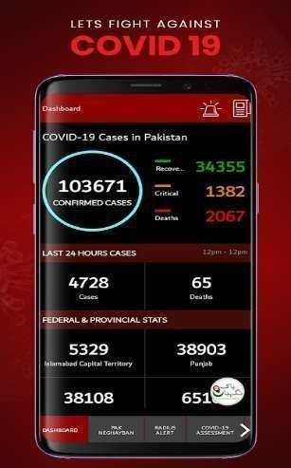

Figure 9 COVID-19 Gov PK

## **2.4 Proposed Solution**

We have added few research papers that are related to our project some way or another, but our project is not exactly the same as any of them mentioned above. We are developing an application which will be able of providing them a feature of Self-assessment using which they can monitor their symptoms.

# **Chapter 3**

## **Requirement Specification**

## **3.1 Requirement Specification**



## **3.2 Existing System of Project**

Likewise, you read the last chapter, there are some applications related to real-time location tracking of COVID infected patients and real-time data monitoring. There are some applications used for the guidance, but our application is based on the combination of both terms real-time location tracking and real-time data monitoring of the patient.

## **3.3 Proposed System of Project**

In our system we are developing an application using which the COVID-19 infected patients will easily self-quarantine themselves and at the same time will be able to monitor their health condition by providing information about their health thrice a day. They will also be provided with medical assistance in case of emergency.

## **3.4 Functional Requirements**

Following are the functional requirements of our project:-

* Registration
  + The system should be able to register new users and create their unique profile.
* Self-Diagnosis
  + The system should be able to collect data from the patients thrice a day.
* Data monitoring
  + The system should be able to monitor the collected data to check patient's health condition.
* Medical Assistance
  + The system should be able to notify the authorities to provide medical assistance to the patient if his condition gets critical.
* Emergency Call
  + The patient would be able to call for emergency.
* Security
  + The system should be able to secure patients personal information.

## **3.5 Non-Functional Requirements**

**Usability**

* The system should be designed in such a way that patients of every age group could understand it easily.
* Different checks in should be implemented in case any irrelevant data in entered by the user which could lead to crash the application.

**Reliability**

* It should perform best even on heavy load of users.

**Performance**

* The system should be fast enough and should not be lagging or taking time to complete tasks.
* Database should be updated automatically after each information submitted by the patient.

**Supportability**

* The system should be designed in such a way that it will run on low end devices.
* The system is flexible in a sense in case it needs to be upgraded or add latest functionalities then it would be to adapt changes and modification.

## **3.6 Use Case Diagram**

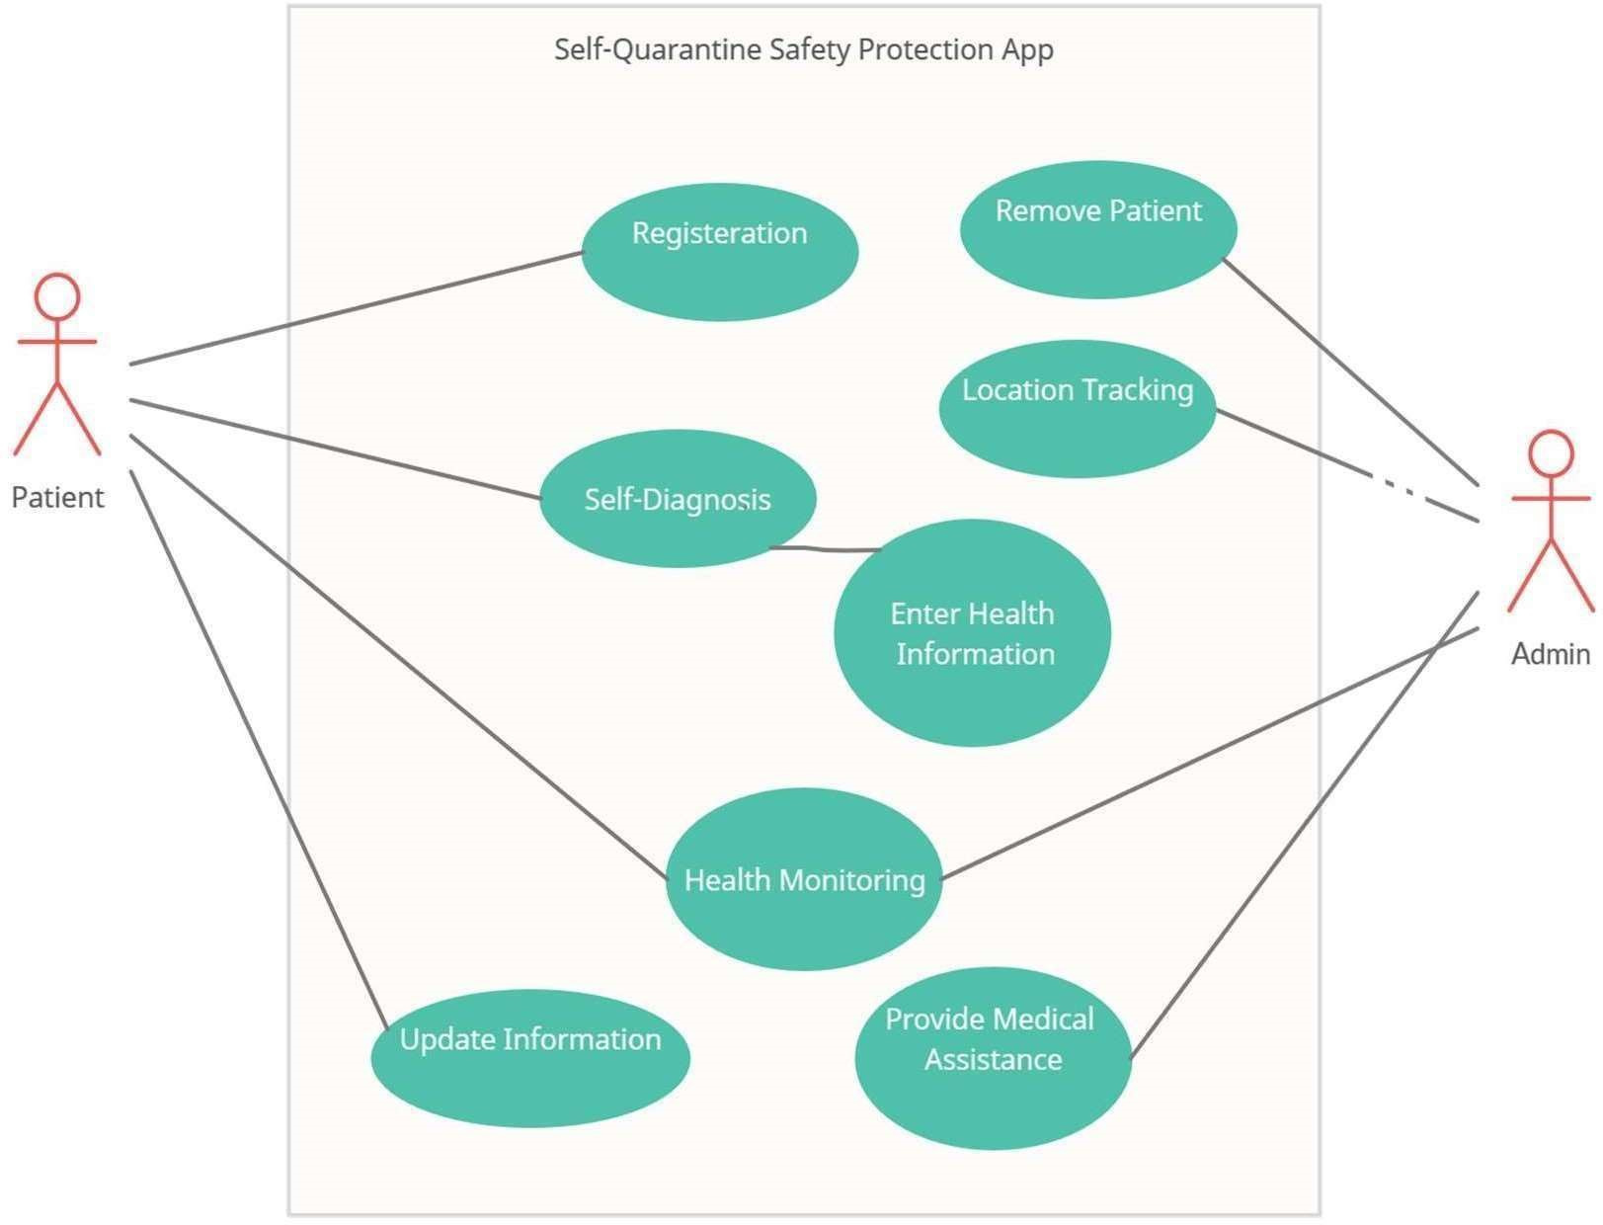

Figure 10 Use Case Diagram

Figure 3.6 shows the application use case which consists of 2 actors, one is patient and the other is admin. The patient is capable of registering himself with valid information. After that he/she can self-diagnose them to get a report of their current health situation. The patients can also update their information like email, password, address etc

## **3.7 Detailed Use Case**

Use cases are a widely used and highly regarded format for capturing requirements. Use cases can help understand the requirements in the way user expect.

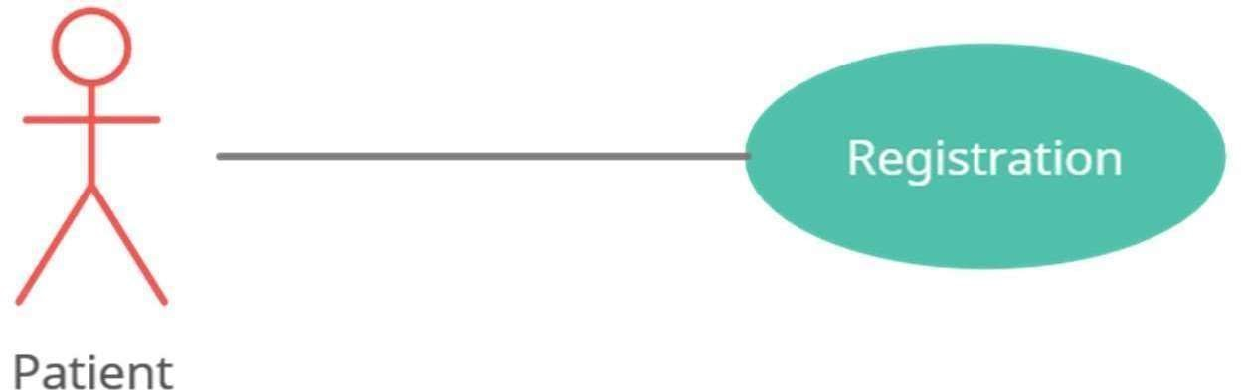

Figure 11 User Registration.

|  |  |
| --- | --- |
| Use Case Field | Description |
| Use-Case Name | Registration |
| Use-Case ID | FR-01 |
| Actors | Patient |
| Use-case Description | Patients will register themselves with required information. |
| Preconditions | Application should be running with a working internet connection. |
| Input Summary | Patient enters the personal information. |
| Output Summary | Profile will be created, and user can interact with the application. |

Table 3.7(a): Registration

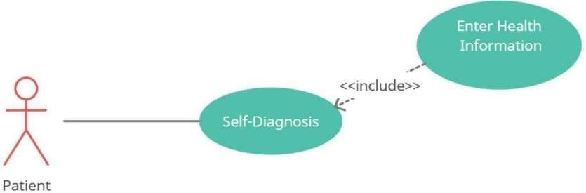

Figure 12 Patient Self-Diagnosis

|  |  |
| --- | --- |
| Use Case Field | Description |
| Use-Case Name | Self- Diagnosis |
| Use-Case ID | FR-02 |
| Actors | Patient |
| Use-case Description | Patient will enter information about their current health condition. |
| Preconditions | The patient should be registered. |
| Input Summary | Patient provides their health information. |
| Output Summary | The provided information is monitored by authorities. |

Table 3.7(b): Self-Diagnosis Details

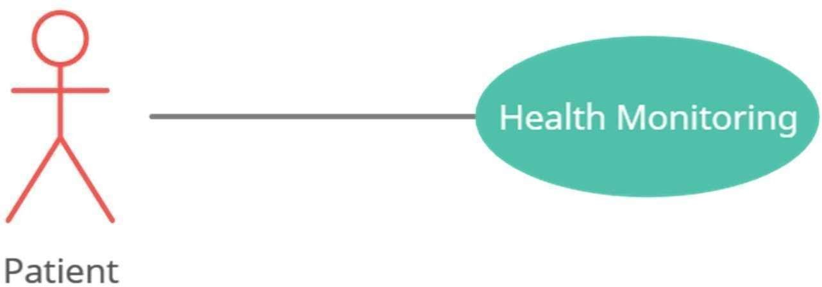

Figure 13 Patient Health Monitoring

|  |  |
| --- | --- |
| Use Case Field | Description |
| Use-Case Name | Health Monitoring |
| Use-Case ID | FR-02 |
| Actors | Patient |
| Use-case Description | Patient can monitor their condition based on the information they provided. |
| Preconditions | Health condition should be provided in self-diagnosis module. |
| Input Summary | Information about current health condition is entered. |
| Output Summary | Patient will be able to review his condition. |

Table 3.7(c): Health Condition

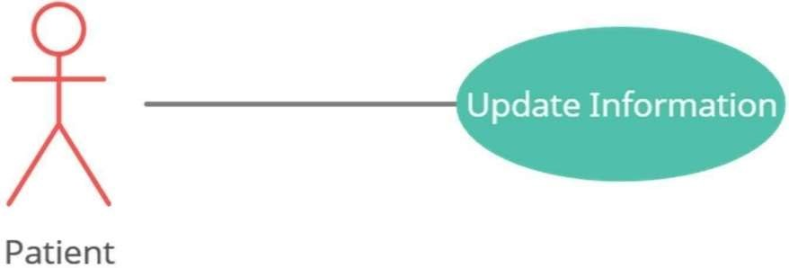

Figure 14 Update Information

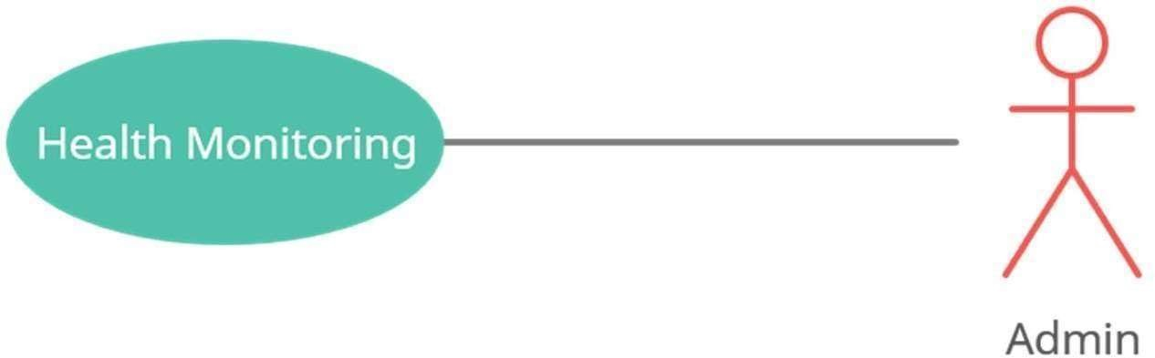

Figure 16 Monitoring Patient's Health

|  |  |
| --- | --- |
| Use Case Field | Description |
| Use-Case Name | Health Monitoring |
| Use-Case ID | FR-05 |
| Actors | Admin |
| Use-Case Description | Admin can monitor patient’s health condition based on the information they provided. |
| Preconditions | Patient must update the system with his/her latest health condition. |
| Input Summary | Authorities will analyze patient covid symptoms |
| Output Summary | Patient current health condition status will be provided. |

Table 3.7(e): Monitoring Patient's Health

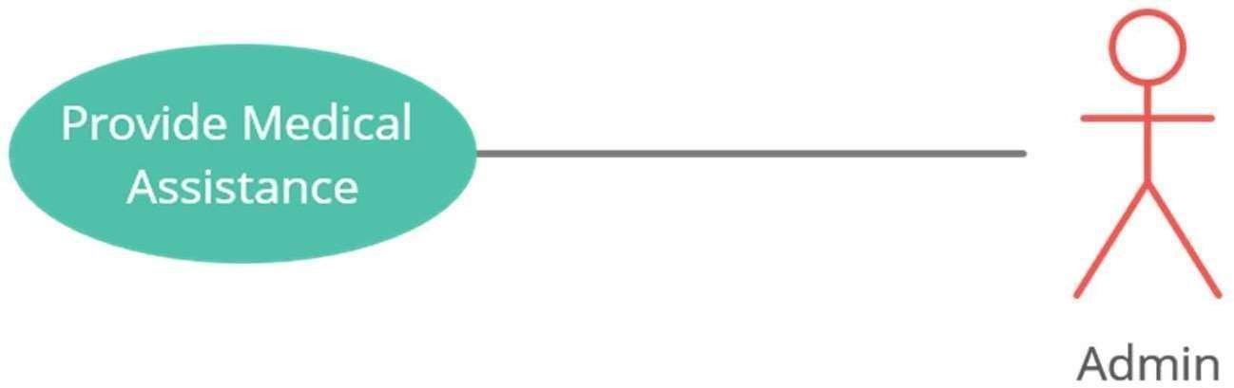

Figure 17 Medical Assistance for Critical Patients

|  |  |  |
| --- | --- | --- |
| Use Case Fiel | d | Description |
| Use-Case Na | me | Provide Medical Assistance |
| Use-Case ID |  | FR-06 |
| Actors |  | Admin |
| Use-case De | scription | Admin can provide medical assistance to the critical patients by carefully monitoring their health condition. |
| Precondition | s | Patient must enter their current health condition |
| Input Summ | ary | Authorities will search for critical patients. |

Table 3.7(f): Medical Assistance for Critical Patients

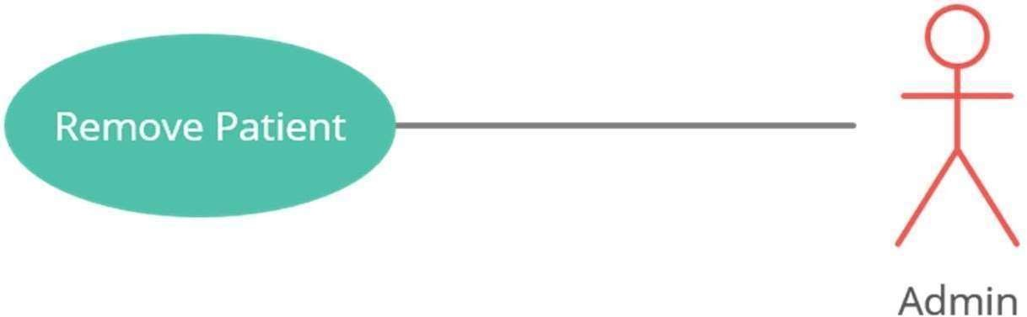

Figure 18 Remove User

|  |  |
| --- | --- |
| Use Case Field | Description |
| Use-Case Name | Remove Patient |
| Use-Case ID | FR-07 |
| Actors | Admin |
| Use-case Description | Remove a suspected fake user. |
| Preconditions | User must be registered |
| Input Summary | Authorities will select a suspected fake user. |
| Output Summary | Patient’s account will be disabled. |

Table 3.7(g): Remove User

**Chapter 4**

**Design**

**4.1 Design**



## **4.2 System Architecture**

Figure (4.1) shows the basic architecture of our application. It is a client-server architecture. It has three roles (Patient, Administrator, and database) GPS is a subordinate system.

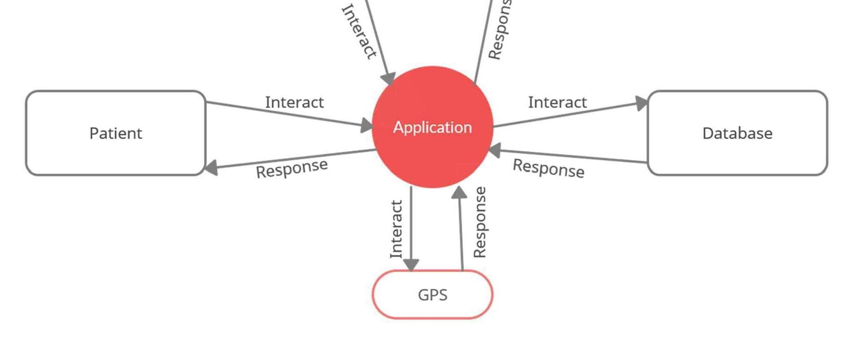

Figure 19 Client-server architecture

## **4.3 Process Mode**

In Figure (4.2) there is process model diagram which shows the working of the entire application from a top level. Considering all possible conditions and processing.

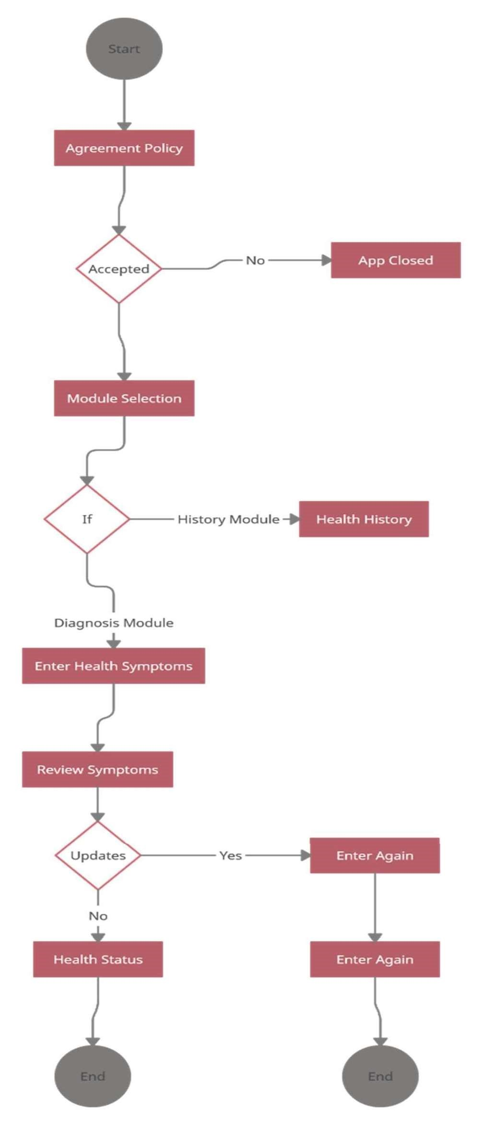

Figure 20 Process Model Diagram

## **4.4 Data Flow Diagram**

In figure (4.3), there is a data flow diagram when patient open this application for self- diagnosis. It shows how to data is monitored and saved into database. How the admin can fetch patient’s location and information. It also explains the alarming system through which the admin is notified if a critical patient is detected by the system. The Location is updated using a location update module.

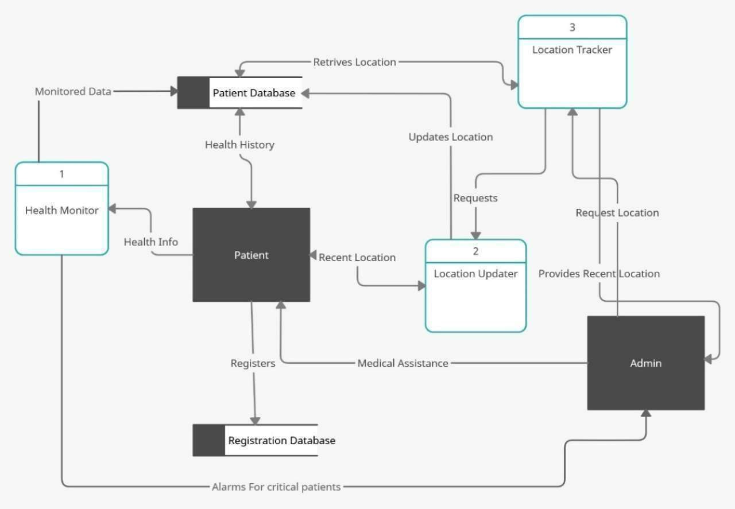

Figure 21 Data Flow Diagram

## **4.5 Sequence diagram**

The sequence diagrams show how the different modules are working in the applica tion. What depends on what and what happens after what? In Figure(4.5a) it shows all the steps in sequence that are performed for a new patient to register to our application. It shows how personal information is gathered and profile is created at the end.

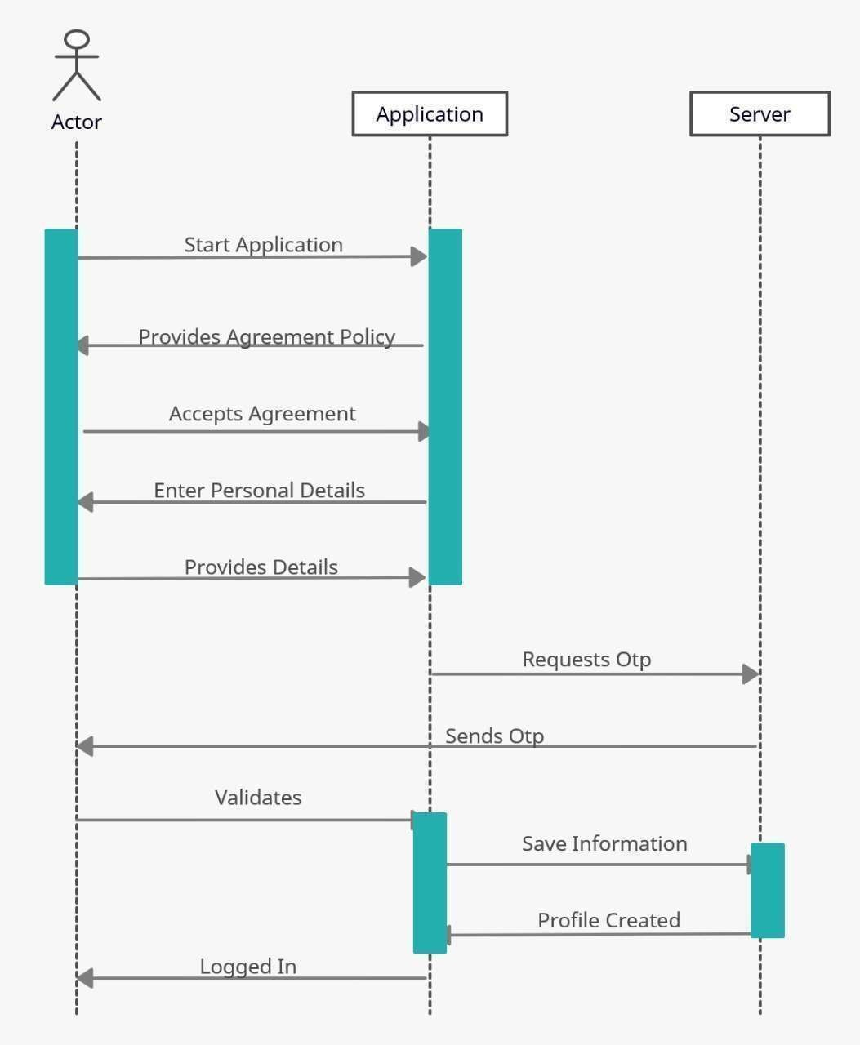

Figure 22 Interaction with Registration module

Figure 4.4(b) shows all the steps that are performed by the system and the user when self- diagnosing. from logging in to submitting symptoms and updating information to database.

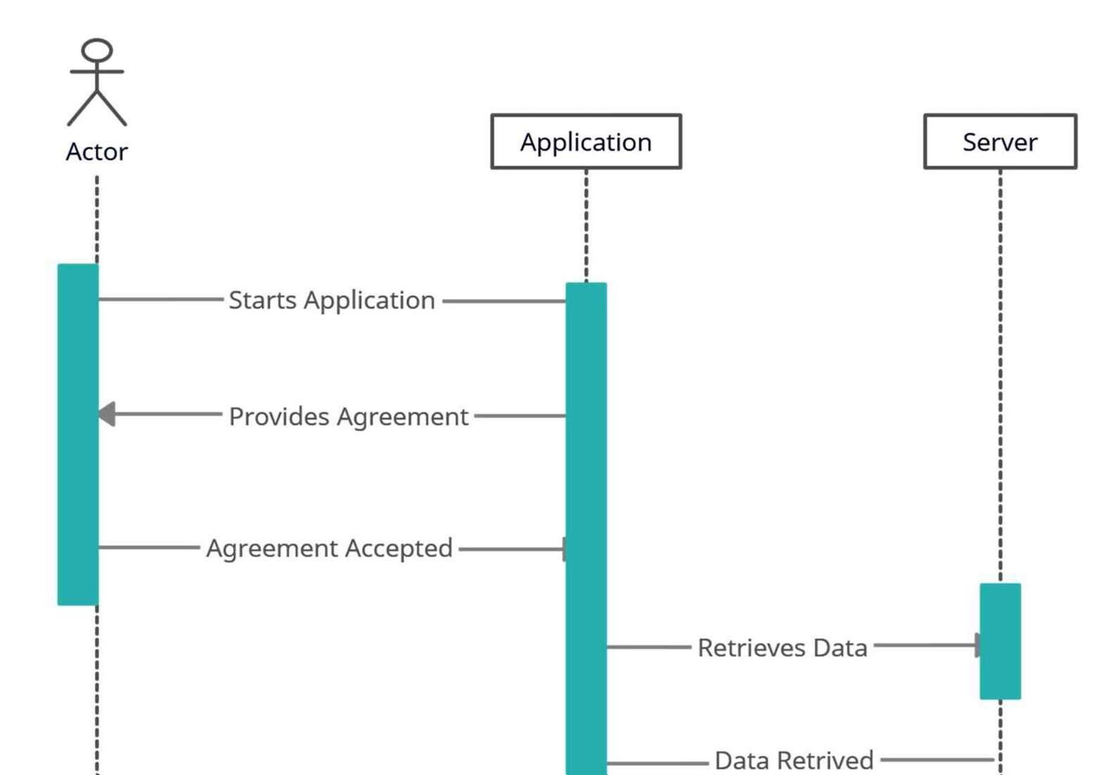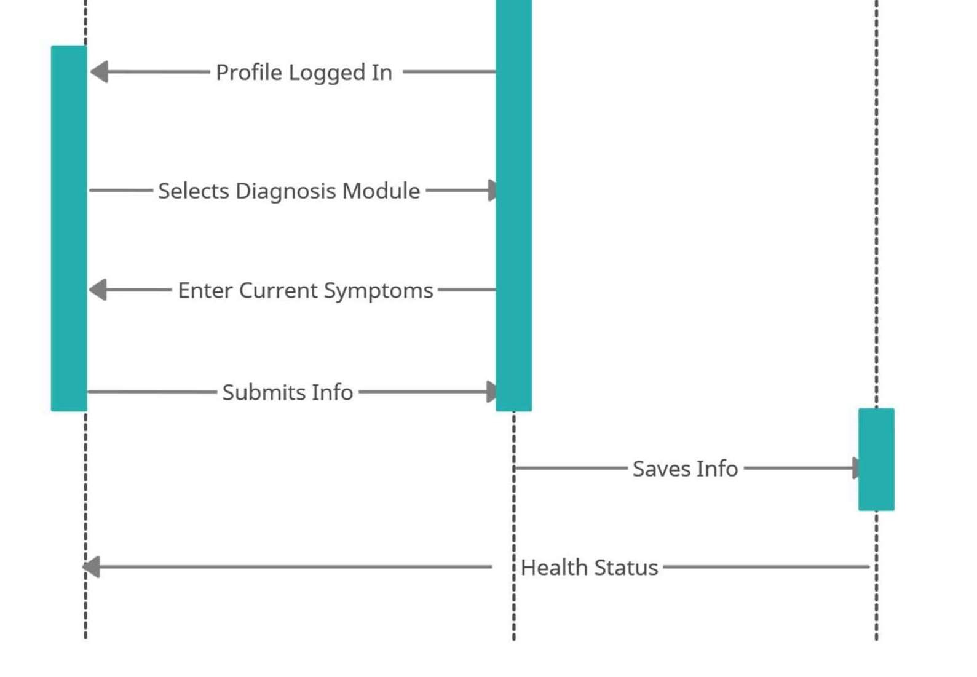

Figure 23 Interaction with diagnosis module

**4.6 Class Diagram**

The diagram in figure (4.5) shows the main entities or roles in our project and how the other classes are accessible by entities.

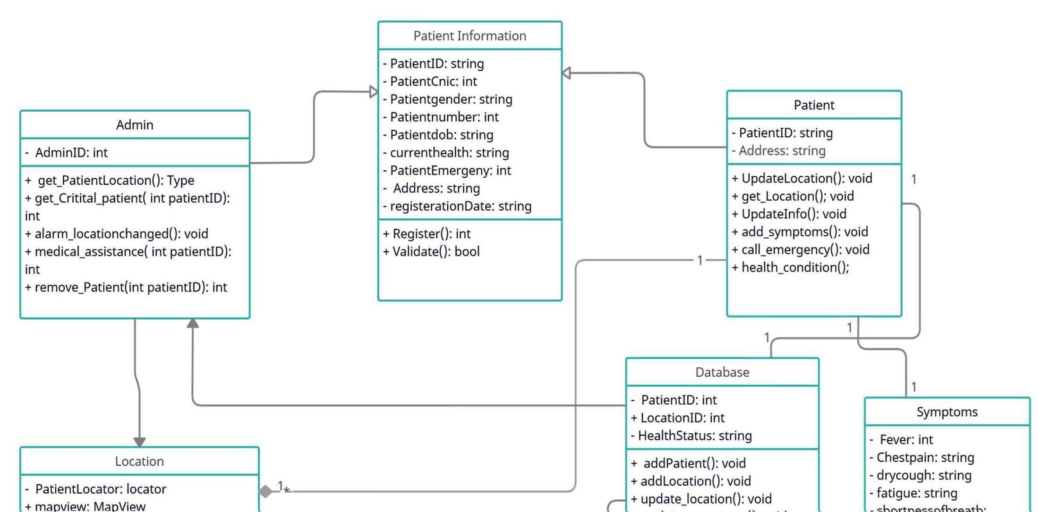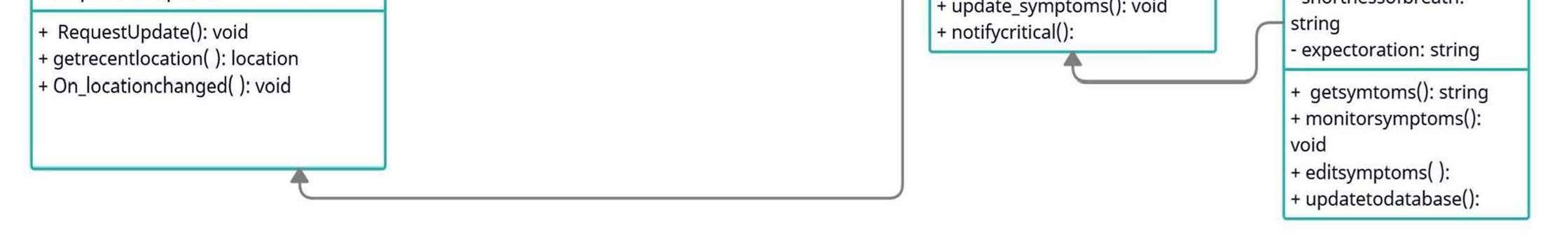

Figure 24 Class Diagram

## **4.7 GUI Design of Project**

The interface of the application is extremely easy for user to understand. The coloring plan is planned to be appealing to the user. The interface is straightforward and Meaningful. The main menu is very easy for user to understand.

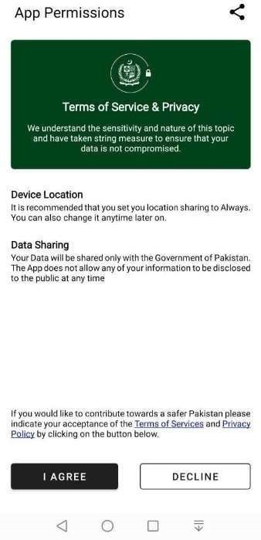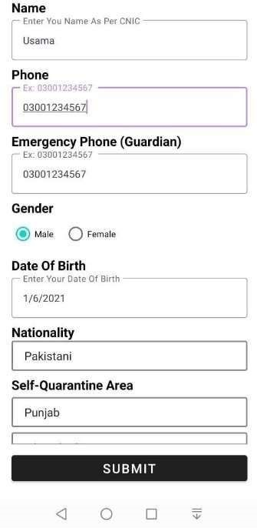

Figure 24 Policy agreement Figure 25 Personal Information

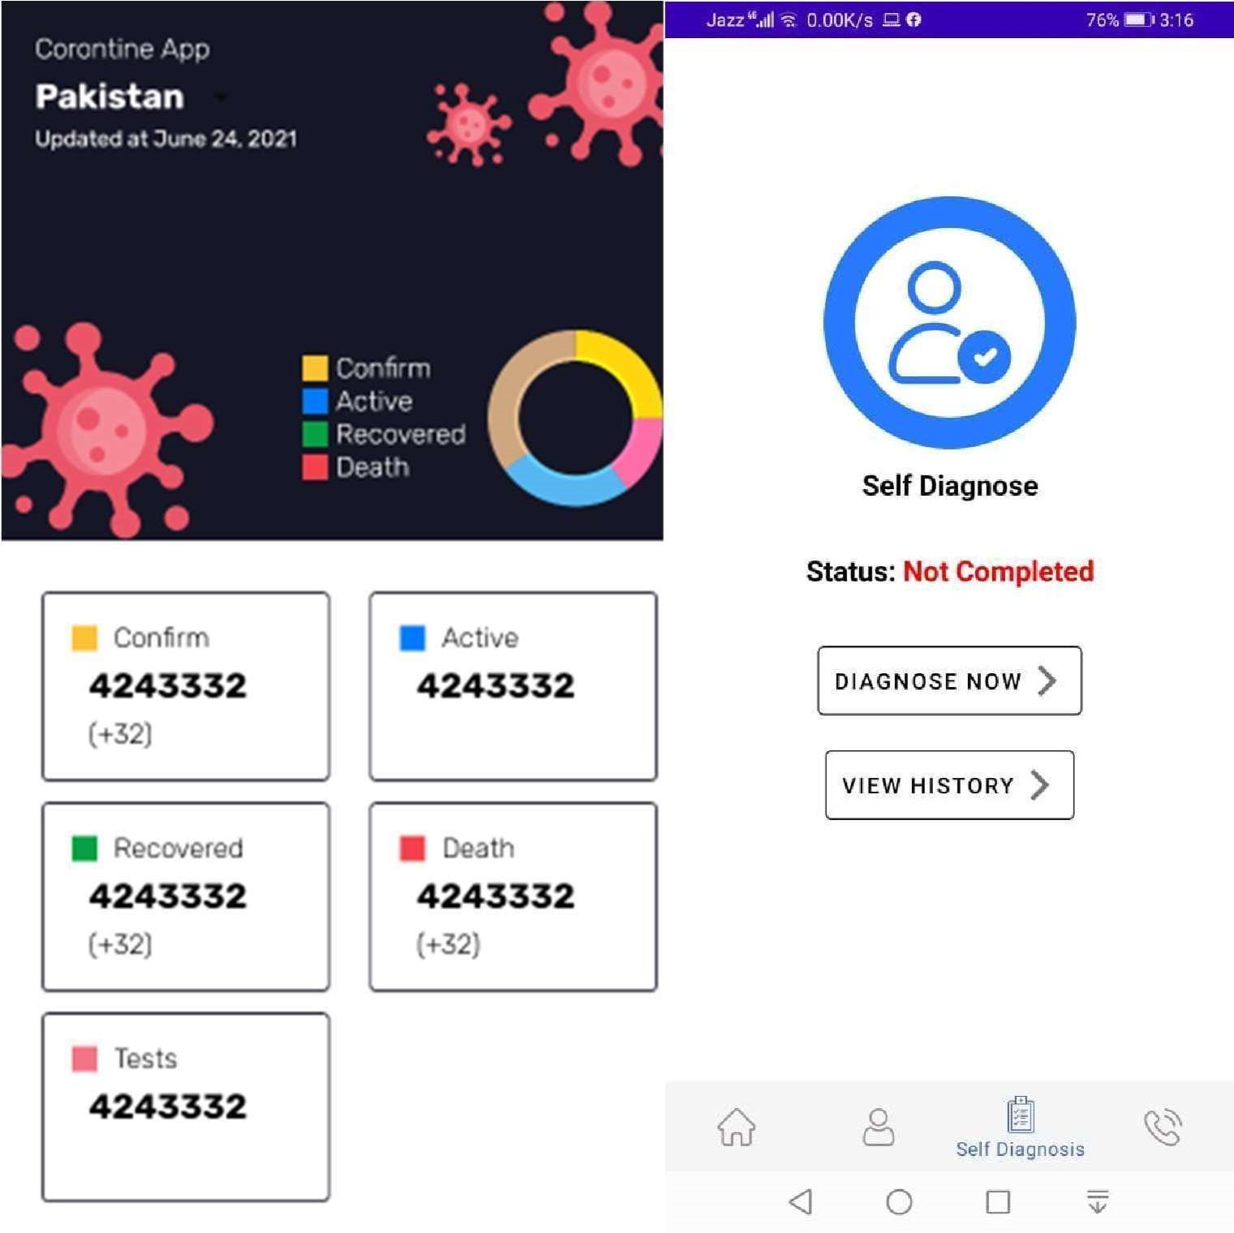

Figure 26 Home Page Figure 27 Self-Diagnosis

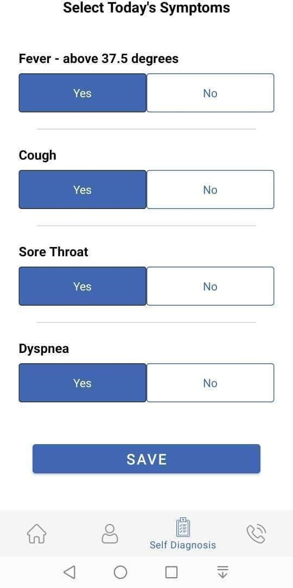

Figure 28 Gathering information

# **Chapter 5**

## **System implementation**

## **5.1 System Implementation**



In this chapter, our main focus is to explain how our system was implemented and the other tools and languages that were used for the implementation of our project.

## **5.2 Tools and technologies**

This application is developed for android based devices. Different tool, languages and libraries are used for the development of the application.

* Android Studio
* Firebase
* Google Maps Api
* Rest Api & Retrofit

### **5.2.1 Android Studio**

The application has been developed in Android studio IDE. Android studio deals with more features that augment the productivity when building android application. It has a fast and feature-rich emulator. It has a integrated environment which helps to develop application for all Android devices. Our application is capable of running on android smart phones from 5.1 to 11.0.

XML: For user interface and layouts we have implemented XML as recognized by Android Studio.

Java: Java is primary language that is used for all the back-end process of our application.

### **5.2.2 Firebase**

Firebase is used as a cloud based server for our project. It is a real time cloud database that can be used to store videos, images etc. The reason for using firebase is that it is scalable and flexible in terms of manipulating data. With the help of firebase it is easy to check our application stats, like total users, daily active users, monthly active users. It is also useful to generate a report for the number of time the application crashed.

JSON: For manipulating data on firebase server we have used JavaScript Object Notation. It is a data interchange language which is used to save information on our server and also to fetch data from the server when needed. The information is saved in the form of “Name: Value”

## **5.3 Libraries and Dependencies**

##### 1. appcompat_version = "1.3.1"

It is one of the package from Android Support library that is implemented in our project. The v7 appcompat library supports our project in the contour of Action Bar, AppCompat Activity, Material design for

* user interface • Gridlayout
* Recycler View
* Vector Drawable library.



###### **2. Firebase-database:20.0.2**

Firebase is a real time database that is cloud hosted and all modules of our project are synchronized to firebase database. It is responsive, works offline and whenever it connects with internet it is updated according to changes done. With assistance of this dependency we are able to upload our database to firebase. It supports data in the form of JSON and it establishes a connection in such a way that the data is manipulated in real time.



**3. Firebase-storage:20.0.2**

Firebase storage is powerful, effective and modest storing facility that is secure and works notwithstanding network quality. It can be used for

* Images
* Audio
* any user generated content

**4. retrofit2: retrofit:2.9.0**

Retrofit is a type-safe REST client for Android, Java and Kotlin developed by Square. The library provides a powerful framework for authenticating and interacting with APIs and sending network requests with OkHttp.

This library makes downloading JSON or XML data from a web API fairly straightforward.



# **Chapter 6**

## **System Testing and Evaluation**

## **6.1 System Testing and Evaluation**



System testing is very important for any system as it check the capabilities of software and makes sure that it get passed through the different validation process. It is done to ensure that every one of the blunders and bugs are expelled that may have happened inadvertently during the usage of the undertaking. In order to achieve the said goal and to minimize the chance of any oddity or aberration occurring different testing and validation techniques are using that are discussed in this chapter.

## **6.2 Graphical User Interface Testing**

It is a process to evaluate that how easily a user can interact with the application using the interface. It also ensures that the GUI of the system is bug free. We have used fashionable color theme to make the application more appealing and accessible. The users are capable of understanding the displayed options easily.

## **6.3 Unit Testing**

All the units of the system are checked and they are performing their functionalities the way they should. It helps in finding out of any module is not working correctly. In our application all the modules are working fine and the user is getting the desired results.

## **6.4 System Testing**

After unit testing all the functionalities are gathered in the system and tested again and system is working completely fine. All the modules are integrated with each other.

## **6.5 Usability Testing**

The usability test executed to meet the user satisfaction with respect to the application usage. No technical experience is required to use our application. It has a simple interface through which the users will register their selves and can easily use the application.

## **6.6 Performance Testing**

This test provides the result that how efficient is our system and reliability of the applications. Some points that describes our performance testing is given below:

* The user is able to register and fetch his information for the database in no time. The response time is real quick. The only thing that is required for this task is a stable internet connection.
* The system may crash down due to some unknown reasons.

## **6.7 Security Testing**

System without security is useless so our application has valid security measures. The application can only be accessed if the user has an active mobile number. While registration the user must accept the terms and conditions so action can taken against him/her if found in any illegal activity. Registered users data is kept private and cannot be accessed by any other user. Data is not shared with any other organization. Overall our system is completely secure and take cares of all the private data.

## **6.8 Test Cases**

|  |  |
| --- | --- |
| Test Case Id | TC-1 |
| Test Case description | Start Up |
| Initial State | APK file should be in the mobile |
| Input | Select the application from the android launcher on the device |
| Expected Output | The application should be launched without errors. |
| Output | The application is launched |
| Status | Success |

Table 6.1 Install Application

|  |  |
| --- | --- |
| Test Case Id | TC-2 |
| Test Case description | Authentication |
| Initial State | Authentication process to signup |
| Input | 1. Enter mobile number. 2. Receive otp code on phone. 3. Enter that otp code. |
| Expected Output | Sign-In to application. |
| Output | Signed-In |
| Status | Success |

Table 6.2 Authentication Process

|  |  |
| --- | --- |
| Test Case Id | TC-3 |
| Test Case description | Sign-up |
| Initial State | Enter personal information to signup |
| Input | 1. Enter personal Information 2. Enter current address 3. Submit information |
| Expected Output | Enter to main screen of application |
| Output | Shows main screen |
| Status | Success |

Table 6.3 Sign-Up Test Case

|  |  |
| --- | --- |
| Test Case Id | TC-4 |
| Test Case description | Tracking symptoms |
| Initial State | Open Symptoms tracking menu. |
| Input | Enter all the correct symptoms from the displayed options. |
| Expected Output | Show health status |
| Output | Health status shown |
| Status | Success |

Table 6.4 Symptoms Tracking

**Chapter 7**

## **Conclusion**

## **7.1 Conclusion**



This study was intended at developing a system that would provide a feature of self assessment to the users so they can diagnose their health condition based on the predict generated by the system.. All users must pass through the secured authentication process in order to use the application. All the personal information of the users are secured.

After registration the user can check his/her health condition on the basis of the symptoms they are having. The administration can monitor patient’s health condition and provide medical assistance on time. Application is easy to use and is very reliable, and it will help for the administration to fight the contagious disease.

## **7.2 Future Enhancements**

As the Covid-19 pandemic progress additional symptoms might be integrated into future models. In future, the methodology presented in this study may benefit the health system response to future epidemic waves of this disease and of other respiratory viruses in general.